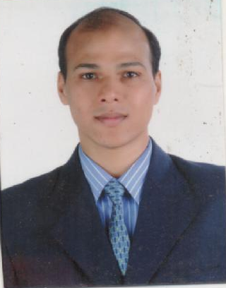
Aditya Wable
B.N.-45,2nd Chourasiya Sector, Sudama Nagar,
Indore 452009, MP, India,
phone: +91-9826422140,
email: wable.a@gmail.com

Objective
Looking for the position of a Technical Analyst in a reputed financial firm. I want to utilize my financial and technical skills towards the growth of the organization.

Skills
- Excellent analytical and mathematical skills
- Excellent ability to understand the fluctuations of the stock market
- Able to forecast about the stock market efficiently
- Possess the qualities of a good team leader and a good team player
- Possess good interpersonal skills
- Possess excellent negotiating and convincing skills

Experience in Capital Via as a Research Analyst at Indore (Jan ’12 to Oct ‘14)

- Responsible to conduct research on the stock market
- Analyze and make predictions on the basis of research
- Working on different computer tools used to analyze about the stock market
- Responsible to mail proper reports on the basis of research
- Assisting and coordinating with the research team
- Handling different tasks related to the job profile

Experience in Rajratan Global Wire Ltd. as a Management Trainee at Pithampur (Nov ’10 to Jan ‘12)

- Maintain accounts payable and accounts receivable records in TALLY(ERP).
- Prepare, analyze, and interpret financial reports, statements and records (e.g., balance sheets, profit and loss statements, amortization and depreciation schedules, etc.).
- Record and documentation financial transactions.
- Preparing Bank Reconciliation Statement.
- Finalization of Accounts.

Training Details
Responsibilities during Internship
Responsibilities include assisting the manager with the preparation and submission of the activity reports and documents. Under the assistance of the manager direct the activities of the branch office and ensure the activities of the sales executives. Maintain confidentiality of the company's or individual's information. Processed paperwork to corporate office, performed data entry and processed invoices.

PROJECTS:
- Major Factors Affecting Movement Of sensex (December ‘07):
- I learn many things while doing this project that how the market (sensex) fluctuate with the movement of other variables like RBI’s monetary policies, inflation, FII, and FDI.
- Equity Valuation In Pharmaceutical Industry (July ‘08):
- Analysis of stock in pharmaceutical industry and various factors affecting it, to assist decision making of stakeholders.
- Effectiveness Of Newsletter/Periodicals (April ‘09):
- Effectiveness of Newsletter / Periodicals as a Public Relation Tool in State Bank of Indore
specifically for internal customers

Academic Qualification
- Completed Masters of Business Administration with specialization in Finance and Marketing from the DAVV University, Indore – 60%
- Completed Bachelors Degree in Commerce from the DAVV University, Indore -64 %
- Completed High School from Lokmanya Vidhya Niketan, Indore, - 60.89%

Personal profile
Date of Birth : 23 Dec 1984
Hobbies and Interests : Playing & Watching Cricket, Listening Music whenever free
Marital Status : Married
Wife Name : Mrs. Anjali Wable
Linguistic Proficiency : English, Hindi and Marathi.( Read, Write and Speak)
Strength : Hardworking, Confident and cooperative

Interests & achievements

- Art of Living Happiness and Rural Course Teacher.
- NCC Cadet.
- Yellow belt in martial arts.
- Participate regularly in different Yoga Camps.
- Basic Knowledge of MS-office

Reference

Declaration
I hereby declare that the information given above is true to the best of my knowledge and belief.
Date Aditya Wable
Place

